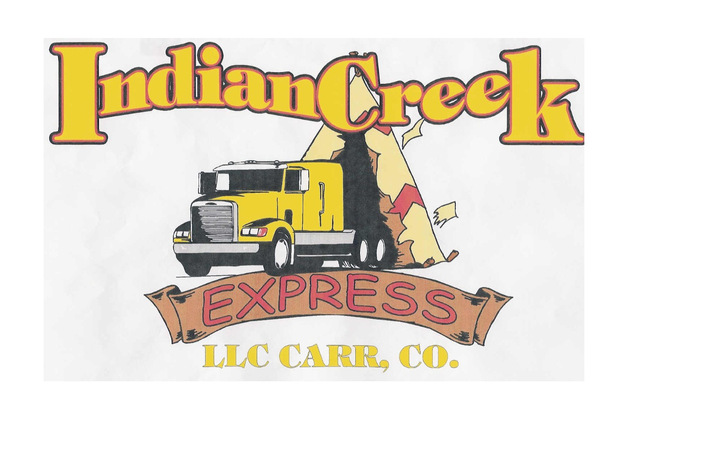
INDIAN CREEK EXPRESS, LLC

Company Snapshot

Established March 1998

Owners

Donne Jefferson Office 970-834-2900 email donne@indiancreekexpress.com
April Jefferson Office 970-568-9528 email april@indiancreekexpress.com

Carrier Information
MC# 397255 USDOT 850216 DUNS 83-988-4819 Safety Rating Satisfactory

Liability/ Cargo Insurance Carrier: Universal Casualty Company Policy # TRCO5000011 EXP 1/15/09
Colorado Worker’s Compensation Carrier: Pinnacol Assurance Policy # available on request, EXP 9/09

Brokerage Information, Indian Creek Brokers, LLC Established August, 2000.
MC#388766

Bonded by Pacific Financial

Common Availability Areas:

Northeast: CT, NH, VT, MA, NY, NJ, PA, VA, MD
Midwest: OH, IN, IL, WI, IA, KY, MI, MO
South: TX, GA, FL, AR, LA, NC
West: OR, WA, DENVER-METRO AND CHEYENNE WY

Due to the competitive nature of our business, we are unable to list references or quote freight rates on our website.

You may contact us directly to obtain a list of our references and discuss your shipping needs.

We are an accredited member of the Better Business Bureau since 2007.

